**Installation of SIERRA**

1. Download and install Neo4j desktop from <https://neo4j.com/try-neo4j/>

Create a Northwind database in Neo4j with following details found in .\SIERRA-master\SIERRA-master\config\webpack.common.js:

new webpack.EnvironmentPlugin({

NEO4J_URI: 'bolt://localhost:7687',

NEO4J_DATABASE: 'Northwind',

NEO4J_USER: 'neo4j',

NEO4J_PASSWORD: 'password',

NEO4J_VERSION: '',

}),

1. In Neo4j Desktop, select Open button of Northwind. This opens the Neo4j Browser in Step 3.

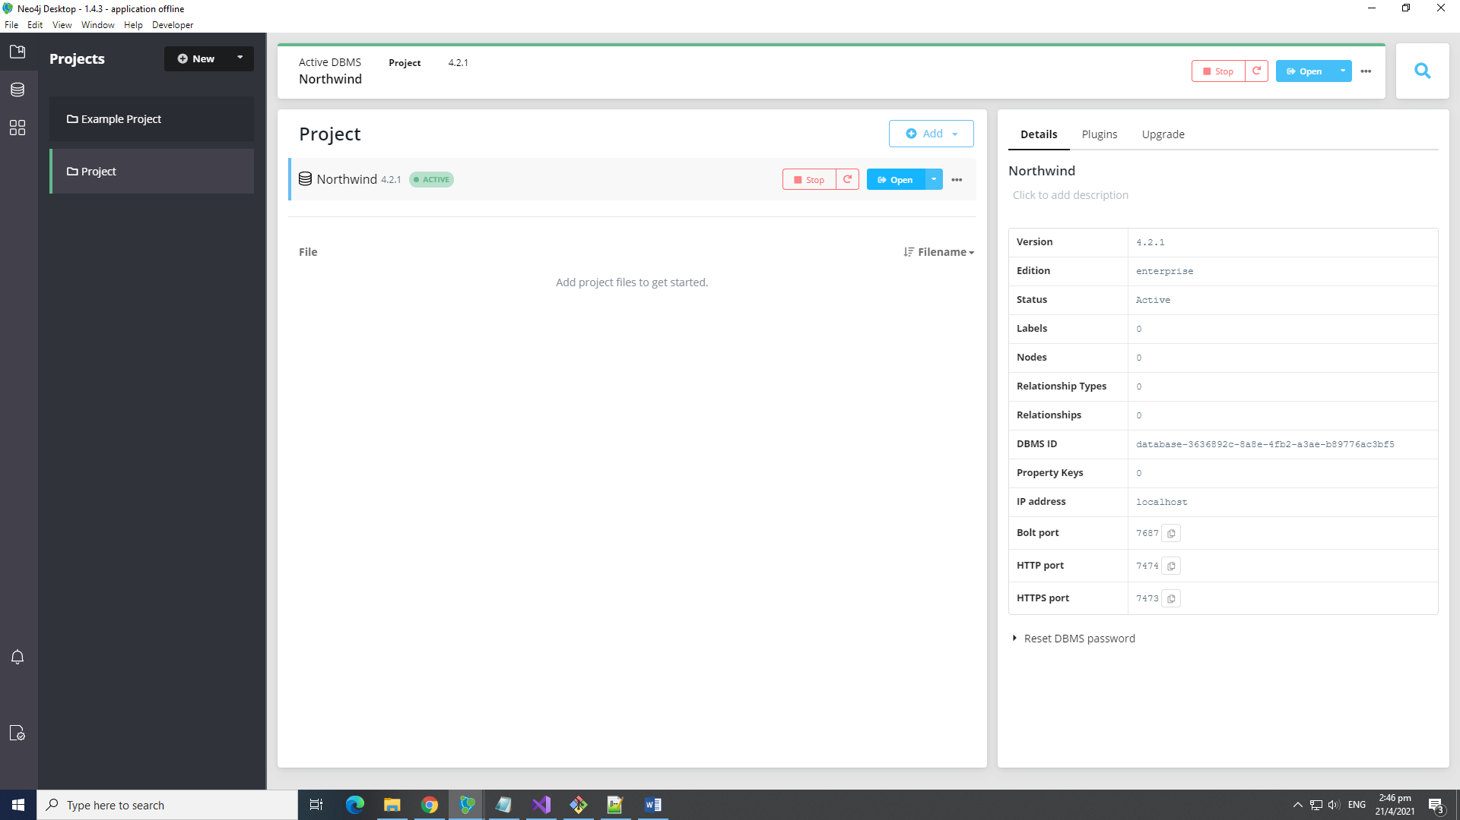

1. In the Neo4j Browser, key in *:play northwind* command in the neo4j$ command prompt. Then click run button (green circled object in figure)

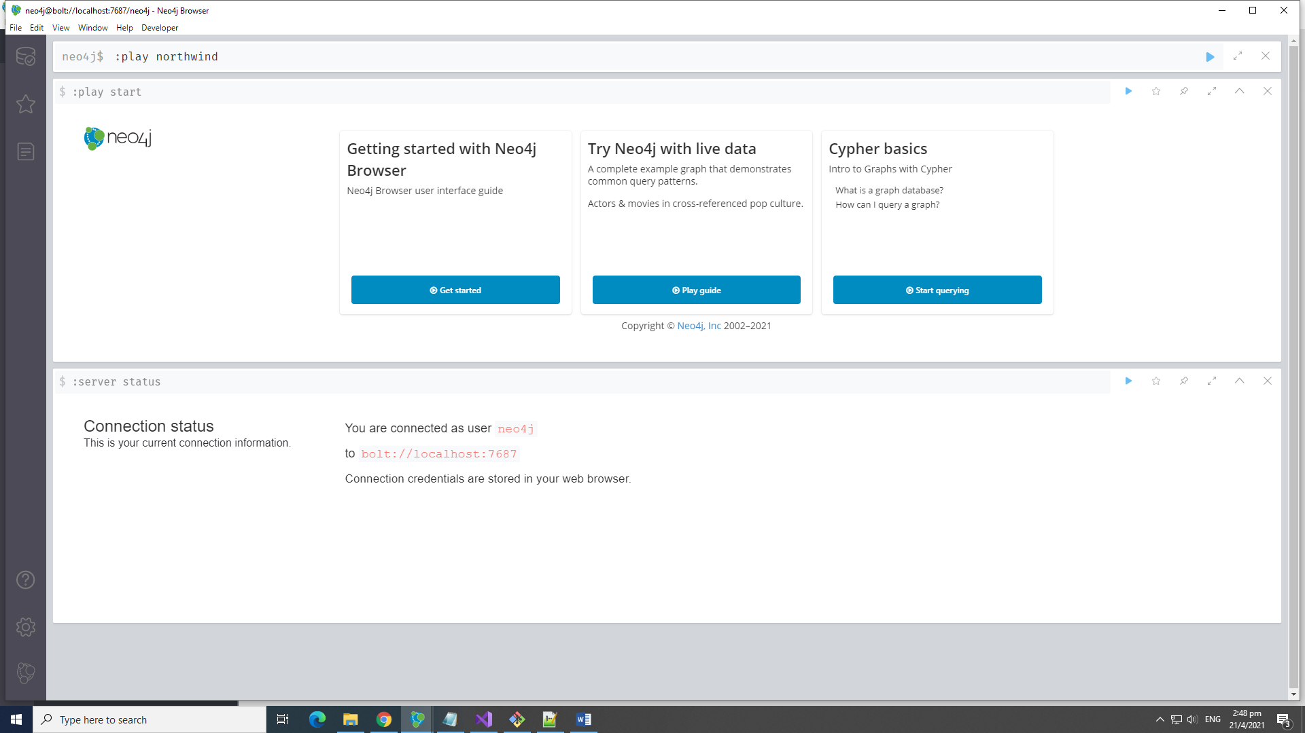

1. The steps for loading a sample northwind dataset (in Neo4j) into the Northwind database will be given. Walk through the steps and run all the commands one-at-a-time by clicking on it (red box in figure) and then clicking on the run button (green circle in figure). At the end of the series of steps, the Northwind database should be populated.

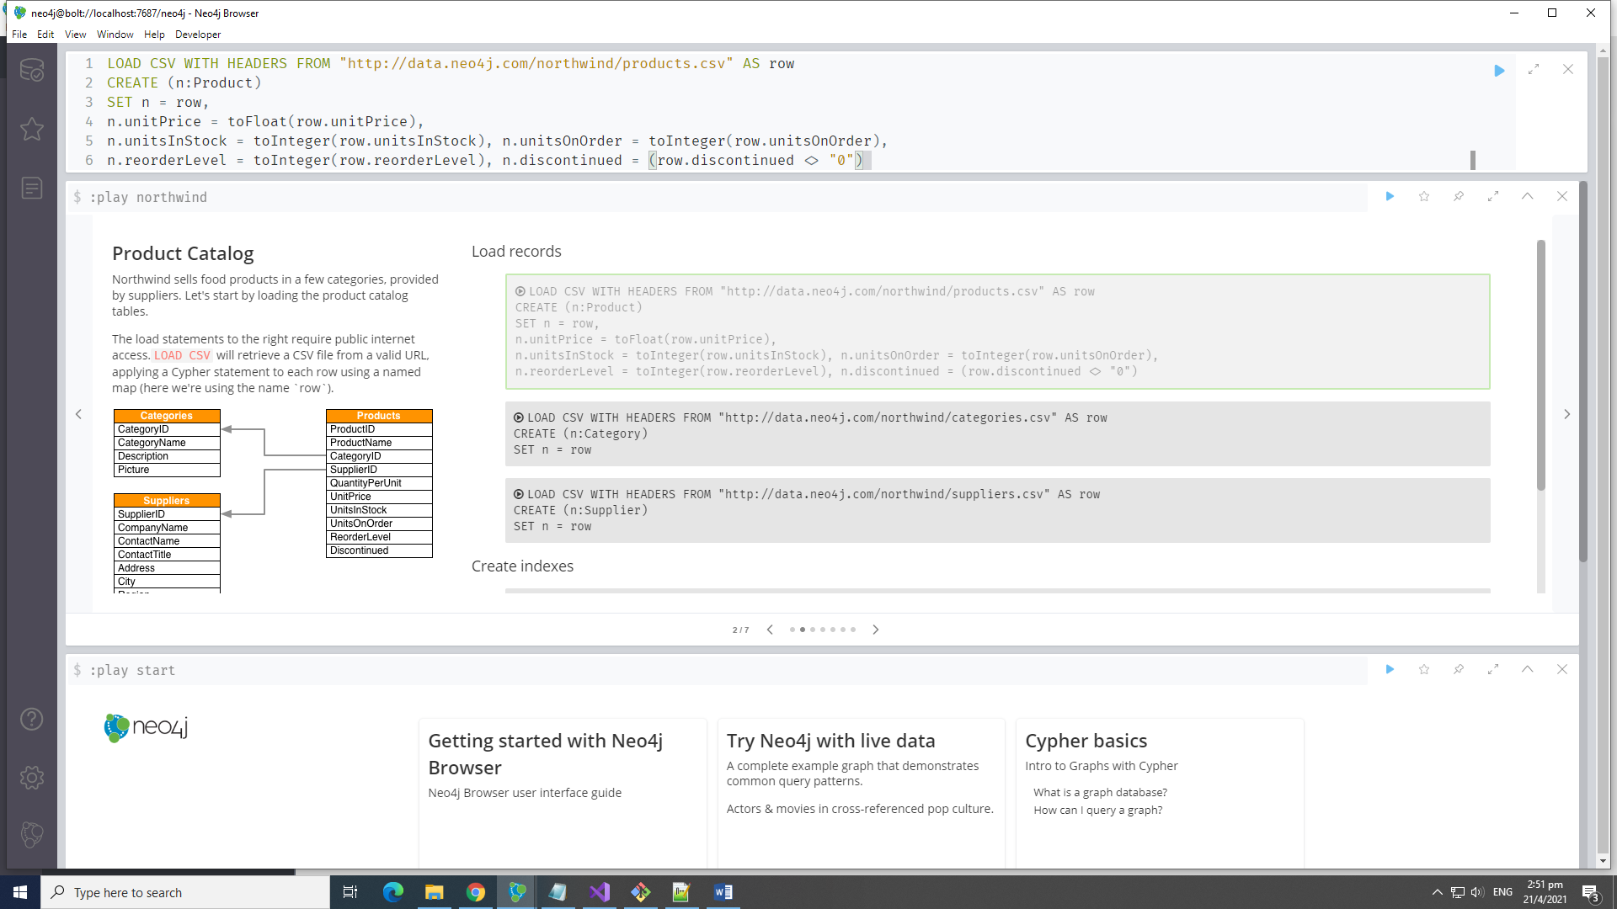

1. To check if the Northwind is populated or not, you can run SIERRA and then click on the + button (green circle). If it is populated, the schema should be shown on the left panel (red box) upon clicking +.

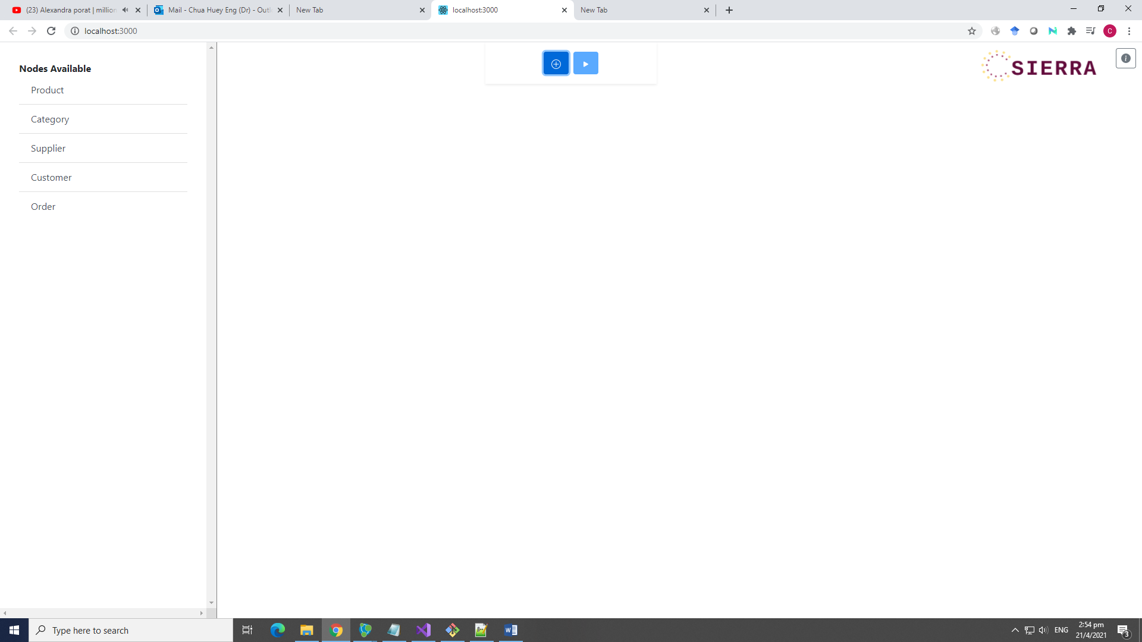

To install SIERRA:

1. Unzip the code (SIERRA-master)
2. Go to the SIERRA-master directory containing package.json (should be ../SIERRA-master/SIERRA-master) and right click at the directory. Select *Git Bash Here*

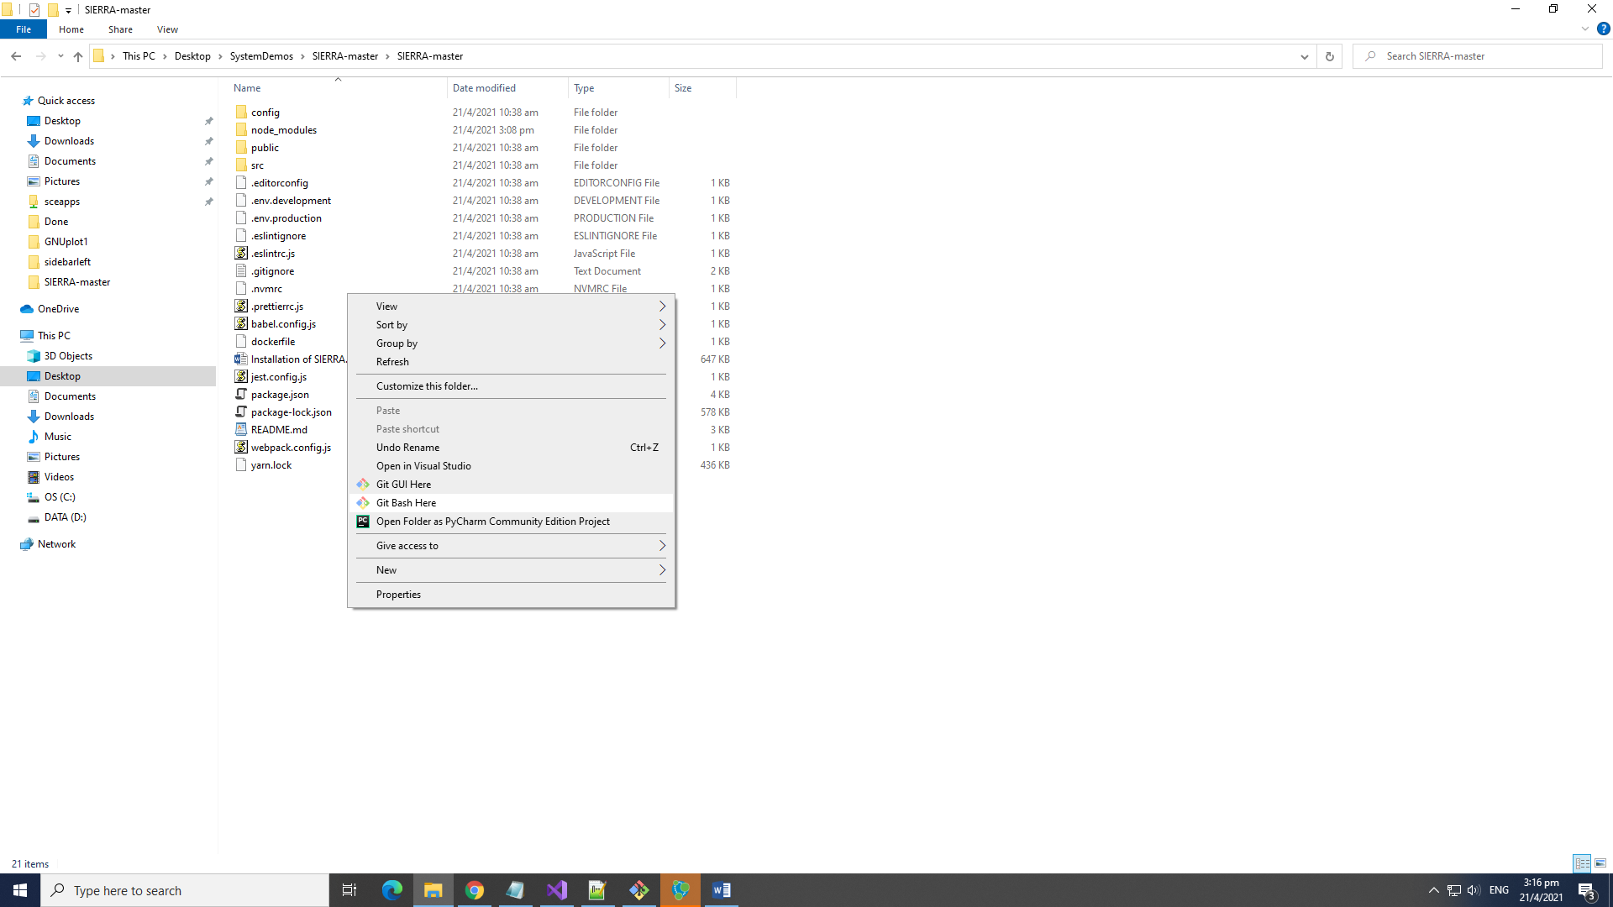

1. This will start the Git Bash app. Input the commands:

*npm install*

*npm run start*

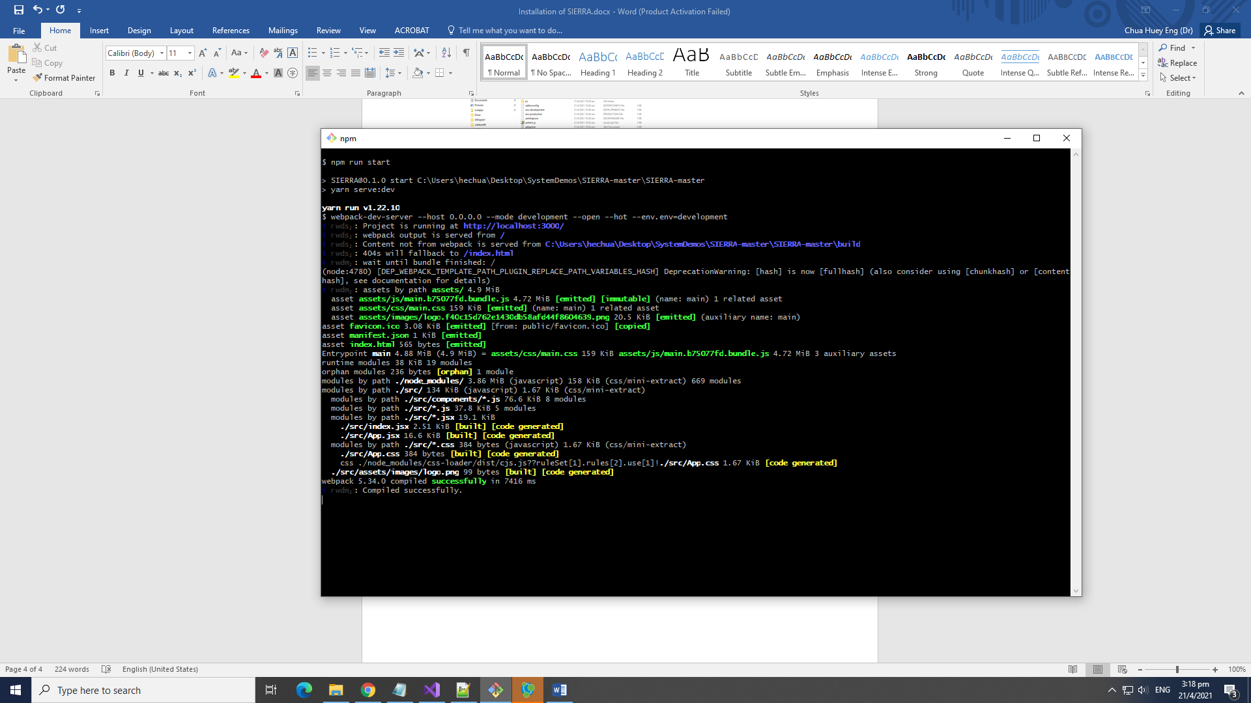

1. Start browser (e.g., Chrome) and go to *localhost:3000* and you should see SIERRA.

